1. Creating pods,service,deployment and replica set :

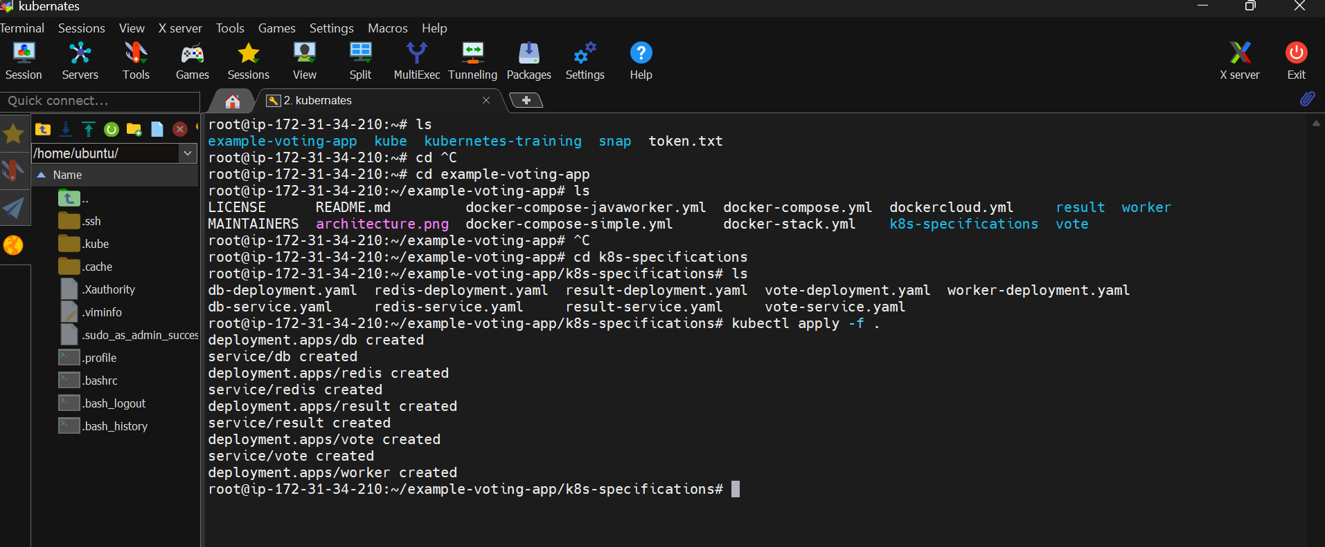

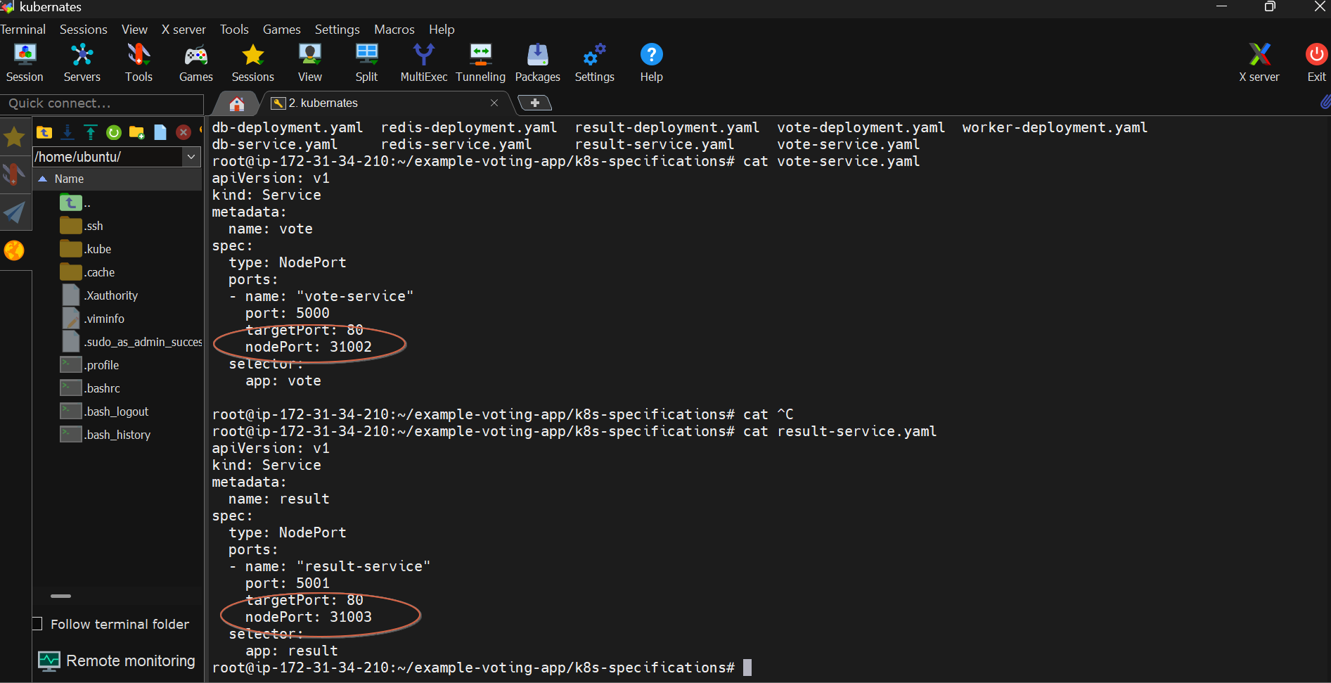

Voter application : http://18.143.138.27:31002/

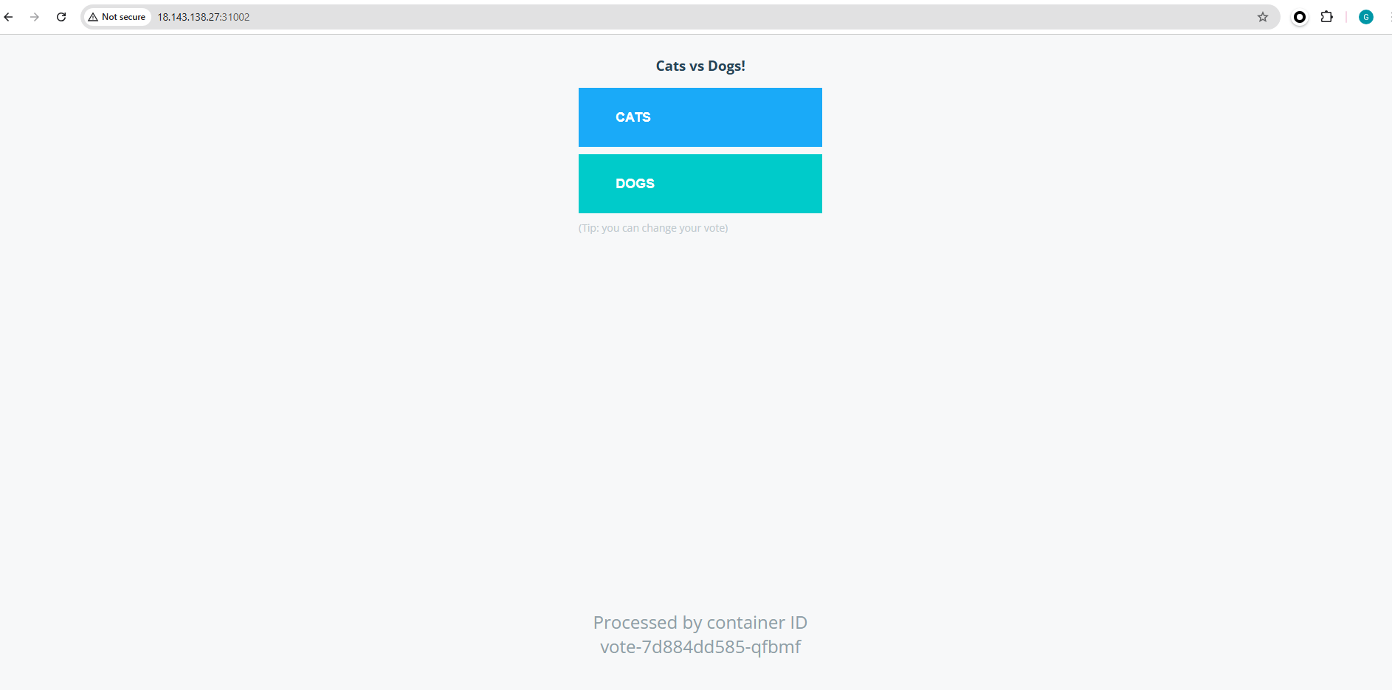

Result application : <http://18.143.138.27:31003/>

Delete vote pod:

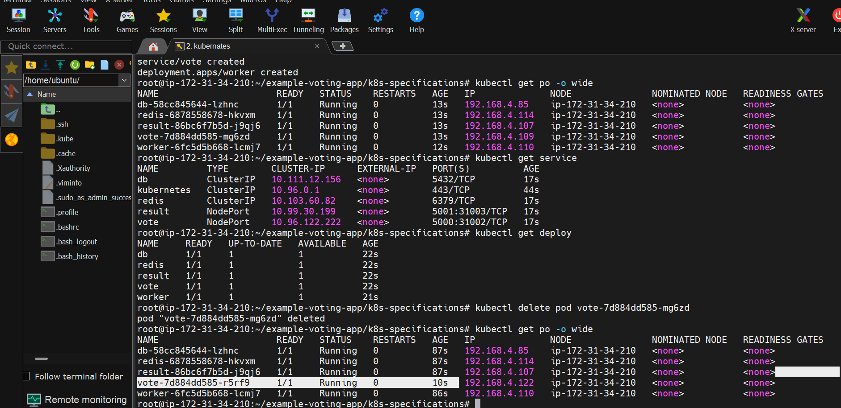

Delete worker pod:

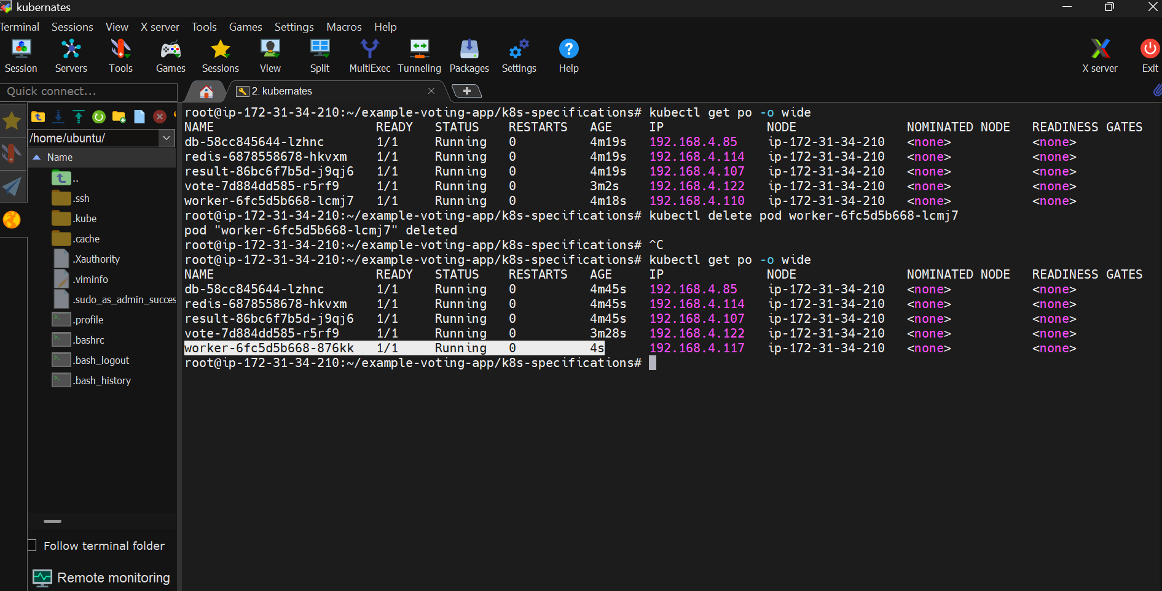

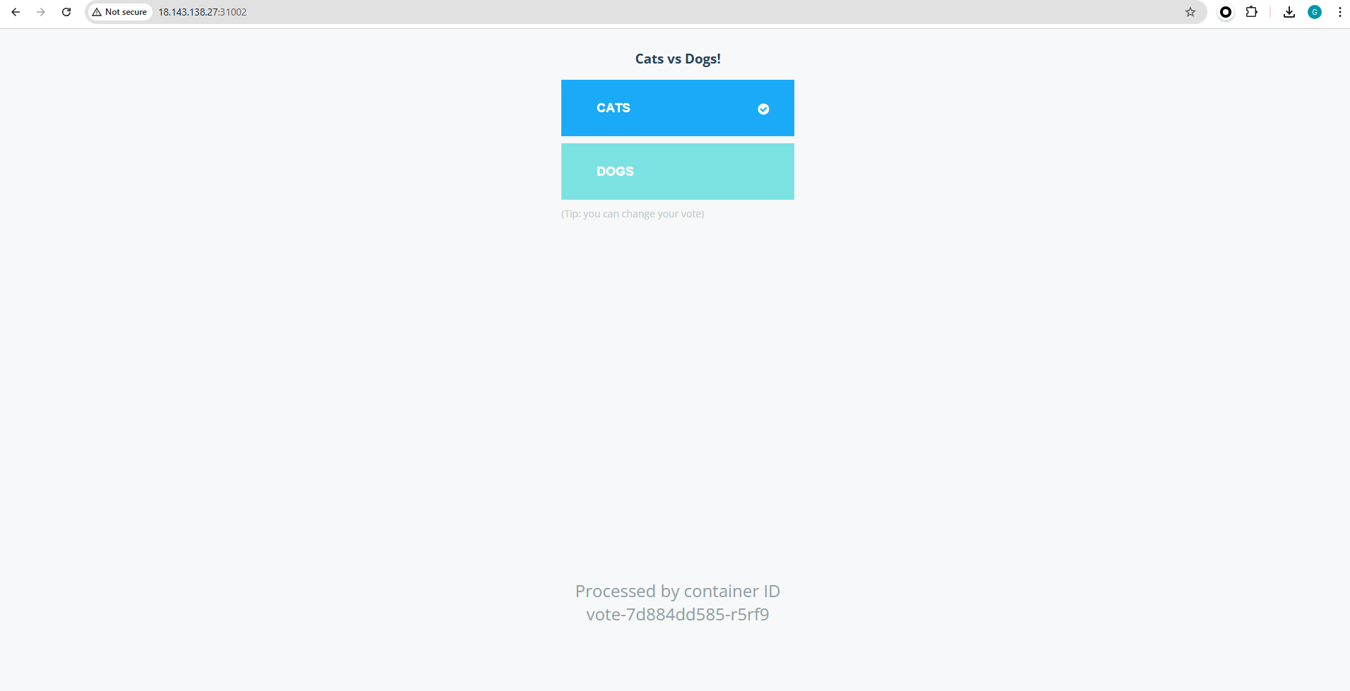

Delete DB pod:

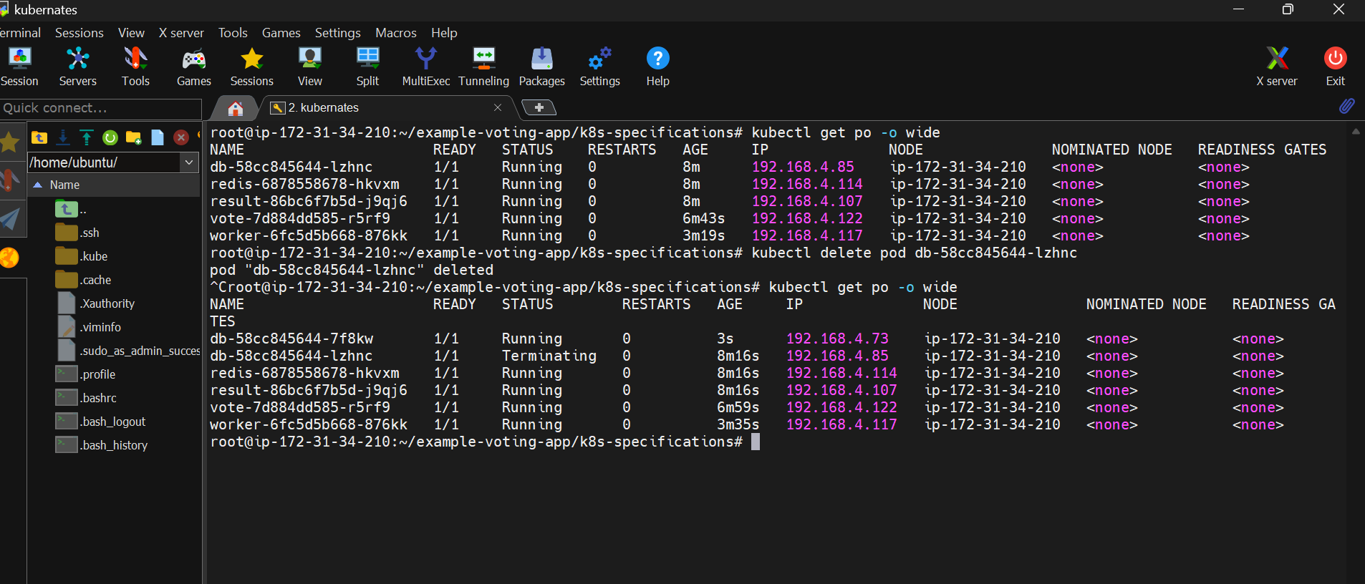

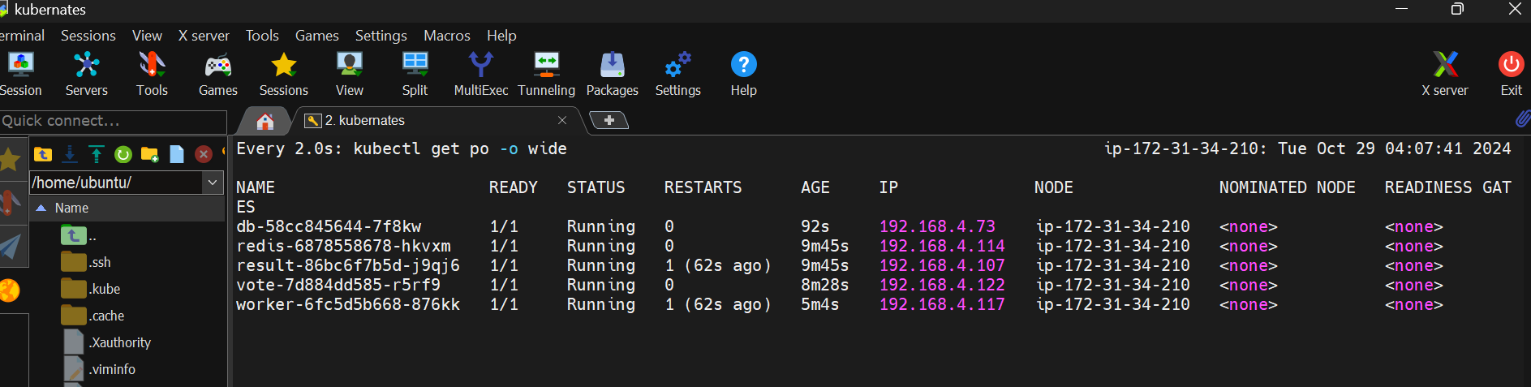

After refreshing the voter pod, the worker pod runs with the latest info:

